Systems Design

Milestone 3

Likhitha Chanda

Professor Griffin

April 13, 2025

Table of Contents

Background 3
Problem Statement 3
Technology Solution 3
Process Maps 4
Functions and Requirements Table 5
User Interface 6
Wireframe 1: Name of Wire frame 6
Description 6
Wireframe 2: Name of Wire frame 7
Description 7
Infrastructure Architecture 8
Network Topology 8
Information Architecture 9
Entity Relationship Diagram 9
Security and Privacy Architecture 10
Programming 11,12,13
References 14

Background

Problem Statement
IniTech was trying to keep inventory of its assets on four spreadsheets; none of the spreadsheets had the same fields and they weren't on the same network. People can't access the same file and no one can keep updated on the file progress. Same item can issue to the other people and it fields miscommunication with no real time inventory update.

Technology Solution
A system where everything is backed on cloud, that has only authorized users to be able to update records. Integrate active directory to set permission of access within the company. Scheduling automated reports would help view regular audits.

Process Maps
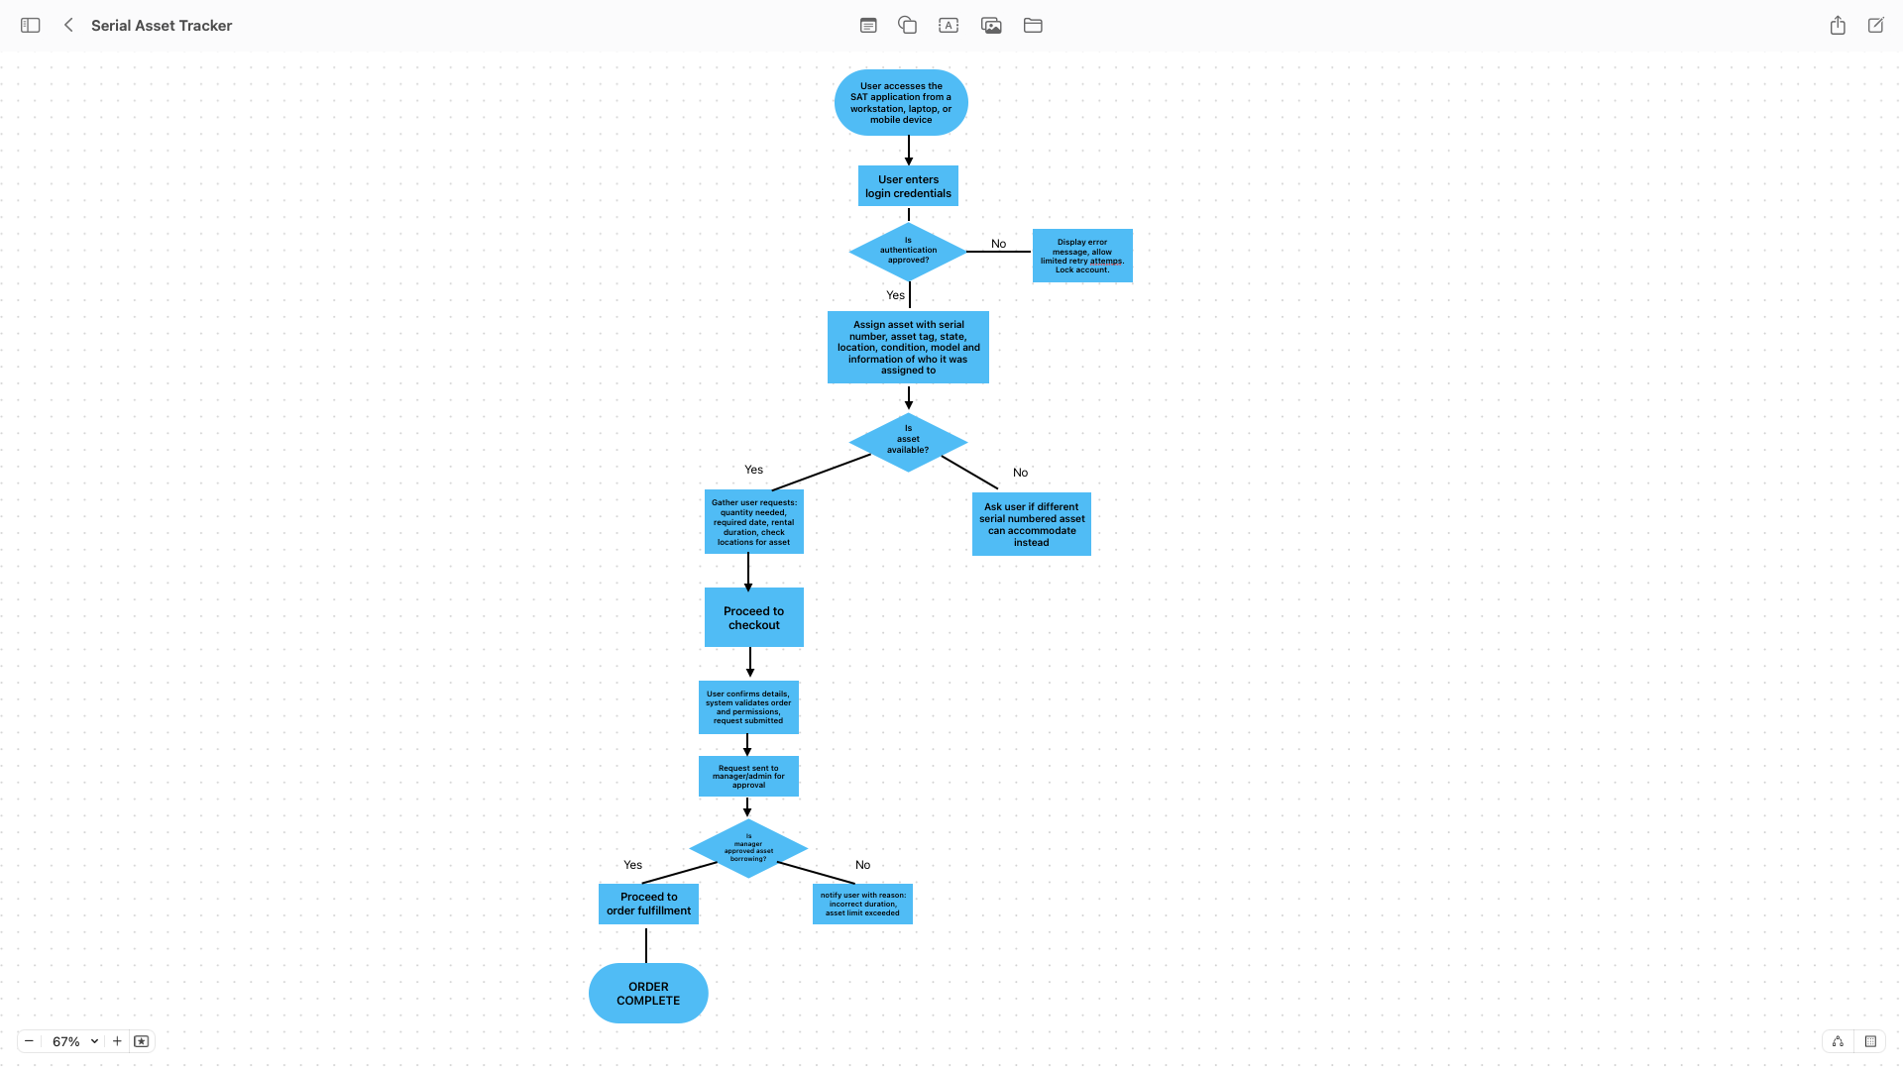

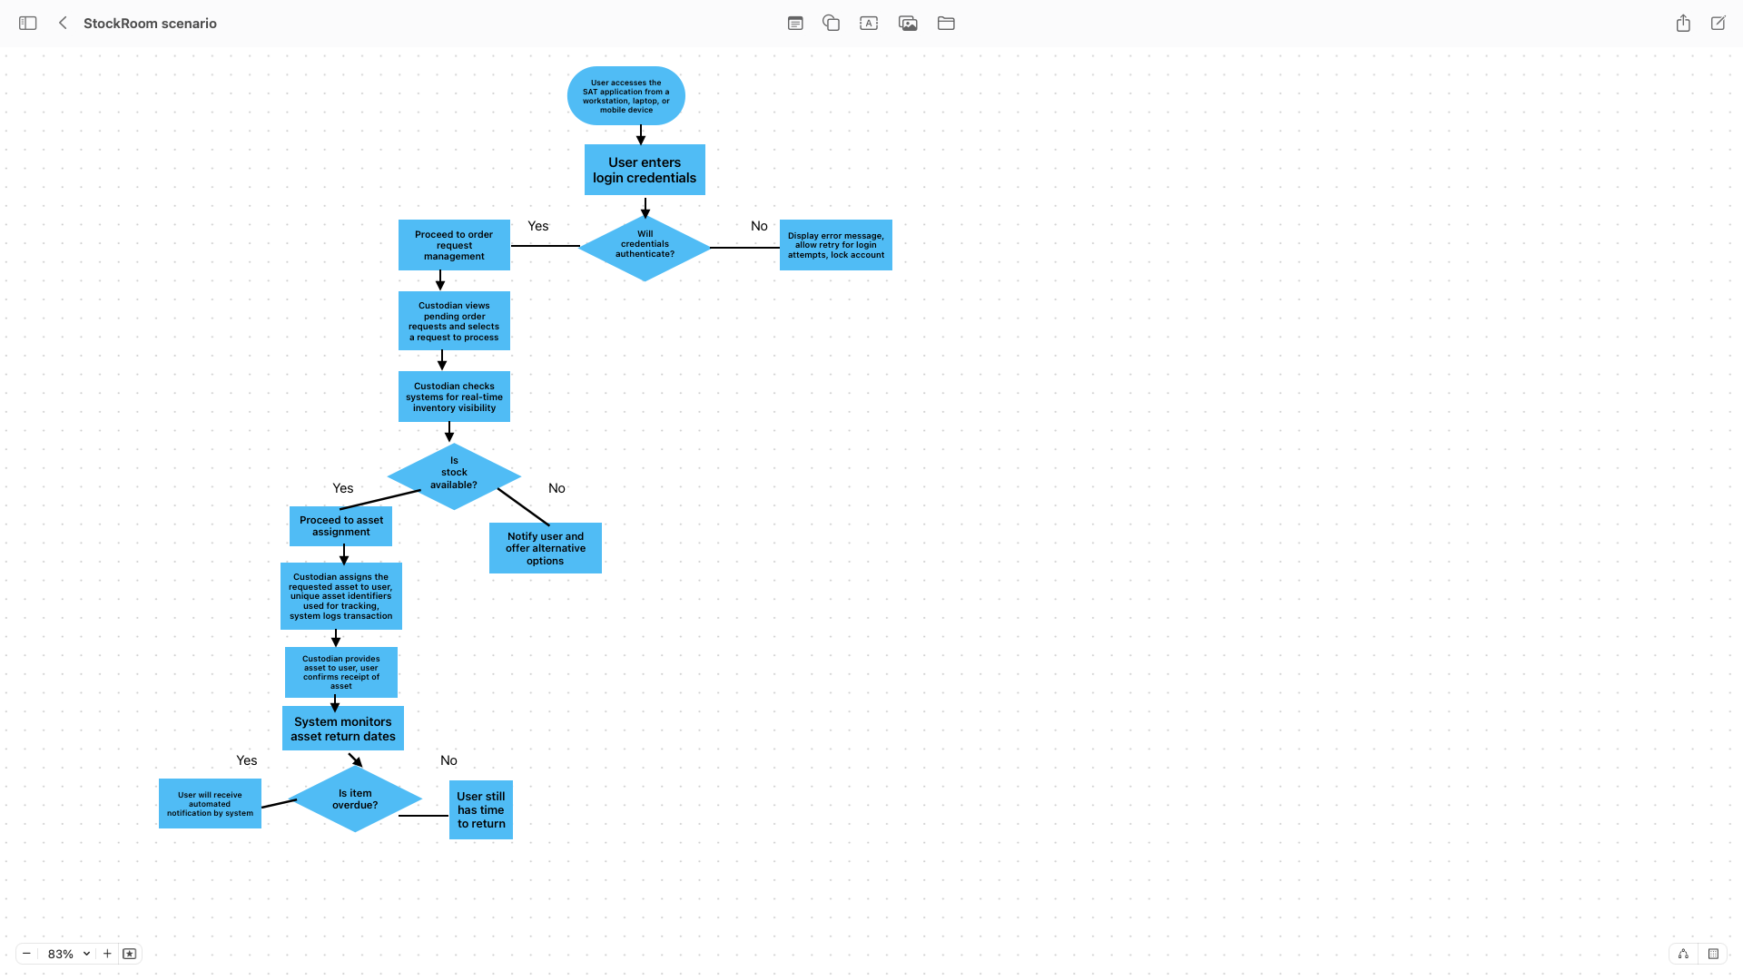

Functions and Requirements Table

FUNCTION | REQUIREMENTS
Purpose  User Login and authentication | - The system msut allow users to login securely  - Use 2FA via email/SMS
Purpose  Asset Check-in/Check-out | - Users can check in and out assets via barcode  - Must log time/user
Purpose  Inventory lookup | - Search assets by type, location, ID, or status  - Filters are available
Purpose  Stockroom management | - Admin can add, delete, or update stockroom data
Purpose  Employee Record Management | - CRUD operations for employee profiles
Purpose  Report Generation | - System can export inventory reports (PDF/Excel
Purpose  Notifications | - Alert for low stock, overdue items or approval needed

User Interface

Wireframe 1: Login Page

Description
Wireframe 1 secures access in the system by checking password and username. This is also through authentication. The first wireframe will by the login screen and details that pertain to it.
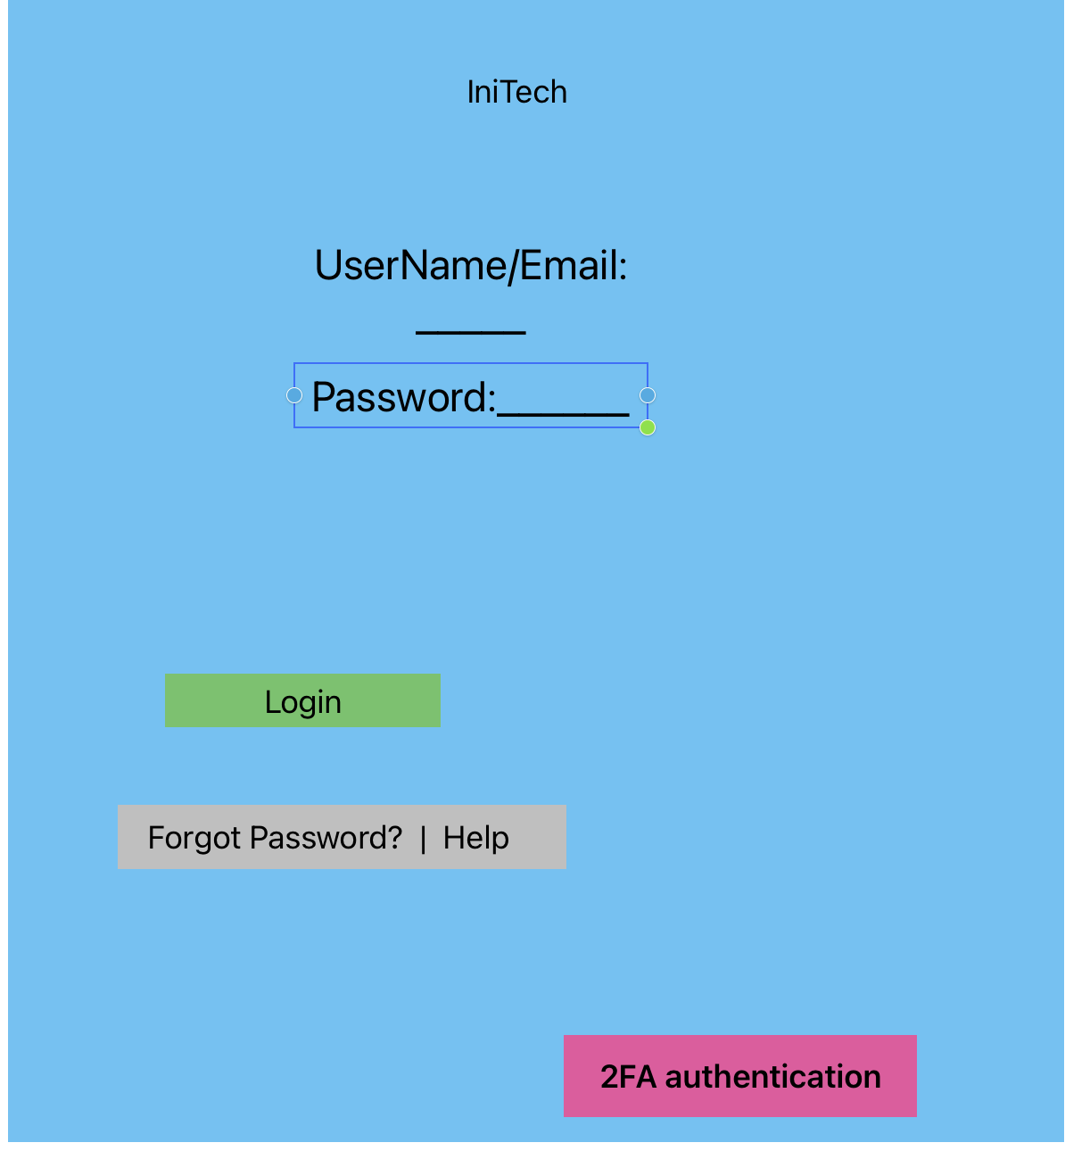

Wireframe 2: Asset Check in and out Page

Description
Allows users to check assets in or out ,with search, barcode entry and transaction logging.
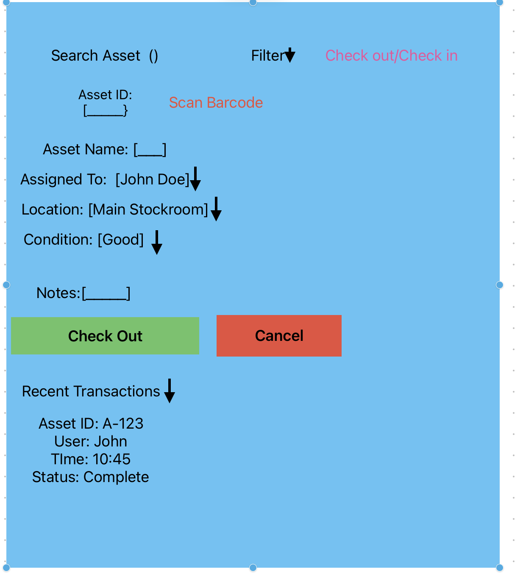

Infrastructure Architecture

Network Topology

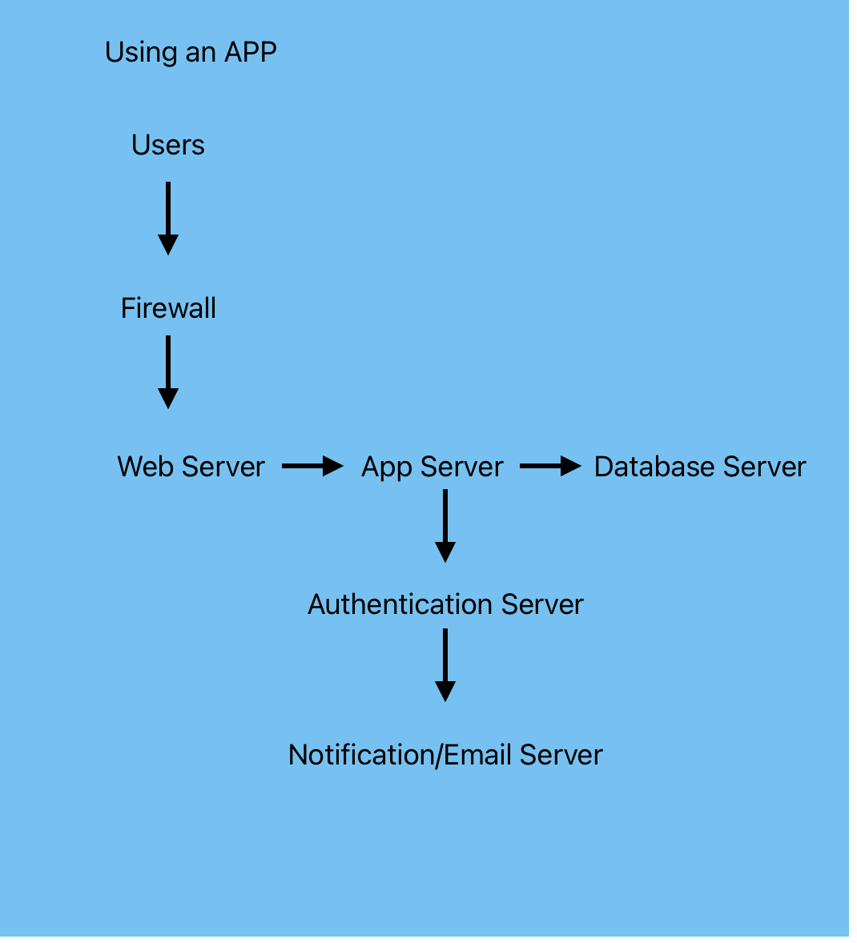

Information Architecture

Entity Relationship Diagram
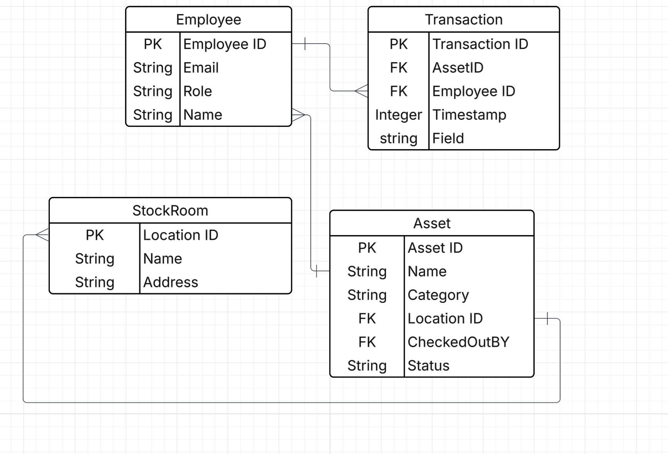

Security and Privacy Architecture

The security goals are to prevent un-authorized access to system and data. To ensure that only valid users can perform specific actions that are role based. It is to protect sensitive data and information such as employee records and inventory records. This will allow to maintain integrity and data availability. This helps the company comply with data protection policies. The purpose of authentication is to reduce risks of unauthorized login attempts, credential theft and session hijacking. To control this a password policy is used along with 2FA, HTTPS, and session management. To restrict user actions based on their roles would also help in authorization, the risks that would be prevented are data manipulation and unauthorized access to sensitive records. To control it using RBAC would help, ACLs and audit logs. Additional security features that would help would be using IDS a firewall and intrusion detection system, Having regular backups and a disaster recovery plan and patch management. The last thing would be security awareness training for staff.

Programming

Technology Tools
ServiceDesk Plus is an optimal tool that would help find solutions to current issues because it works on all OS such as windows, Mac, and Linux. With this feature it is possible for all users with any laptop type in any team who has access to be able to use their device to adapt to this software. It delivers Seamless remote support with ITAM capabilities. It can build a database by scanning SNMP devices and VMs to the network. Having a database is important because it serves as a cloud where you can continue to update and change asset information by having this feature. You can get asset information such as hardware descriptions, what software has been installed, a scan history and asset ownership history and its states. This will help getting automated reports and allow for officers to be able to see and analyze the asset. You can build and maintain a separate inventory to manage any assets that are not related to IT. Using barcode and QR code scanning you can assess the topography. This is important because it helps faster input information about an asset and reduces human error while also tracking real inventory time. Going along with this, there is even an RFID scanning feature that will gather details of multiple assets in bulk. You can create an Asset Relationship Map like a Relational Database with this tool to define relationships and attributes. With your own database it serves as a great tool for the cloud. All of this provides a secure database to store information. Ezo, another software tool, has multiple benefits as well that would help IniTech. This will reduce costs by automating software asset tracking which would identify required licenses. This will also eliminate repeating software that will reduce expense and clutter. It gives better compliance by detecting outdated and at-risk systems through software asset tracking to reduce risk of non-compliance related penalties by updating software and license renewals. It has a benefit of efficient procurement planning which helps plan IT needs which can lead to proper resource allocation with minimized overhead costs using better utilization of existing software’s. Cybersecurity is another benefit because it tracks cloud and on-premises software’s practicing those protocols and it limits software access to authorized users which would eliminate the risk of a data breach. It also prevents over licensing and enables your business to avoid unnecessary expenditures and redistributes licenses for more productivity. Lastly it prevents software hoarding by managing software assets by detecting repeated applications and saves resources. One other IT solution would be by using AWS, AWS offers multiple services that would reduce costs by migrating to the cloud and it offers Asset Management. Asset Management in Aws is using AWS systems manager which allows for inventory management for IT assets, helping tracks software, hardware, and configuration changes. AWS config allows to be compliant with governance tracking by continuously monitoring asset configurations. AWS IoT asset tracking uses IoT technology that tracks physical assets. Amazon RDS & DynamoDB stores data and manages it. AWS Lambda and API gateway allow for automated workflows, allowing real time asset tracking.
Current Solutions
An IT solution currently in the market to solve this issue is ServiceDesk Plus. ServiceDesk Plus is a comprehensive IT service management (ITSM) software by ManageEngine that provides a single platform for managing incidents, service requests, asset tracking, knowledge base, and self-service portals, essentially acting as a help desk tool with additional features for managing IT infrastructure and assets across an organization (AWS 2025). Another solution would be ezo optimized IT software Asset Management. This software helps reduce costs, gives better compliance, efficient procurement planning, airtight cybersecurity, prevents over licensing, and prevents software hoarding. Another It Solution would be to use AWS; AWS uses many services that help create an IT infrastructure on the internet. It helps reduce costs by having scalability and only pay for what you usen as you go. It has the ability to add and delete services when needed(AWS 2025). AWS also offers Asset Management with multiple tools to be able to identify IT needs. Using AWS System Manager, AWS Config, AWS IoT Asset Tracking, Amazon RDS & DynamoDB, and AWS Lambda & API Gateway.

References
AWS Marketplace: It asset management. (n.d.-b). https://aws.amazon.com/marketplace/pp/prodview-n7fgpqjssx4k4
ManageEngine. (n.d.). Top-notch it inventory management for Informed Business Decisions. IT inventory management. https://www.manageengine.com/products/service-desk/it-asset-management/itinventorymanagement.html?network=g&device=c&keyword=it+asset+inventory+solution&campaignid=9233529077&creative=416308233322&matchtype=e&adposition=&placement=&adgroup=93391528226&targetid=kwd381536228102&location=9030097&gad_source=1&gclid=Cj0KCQiAoJCBhCSARIsAPhdfShJz9npBqb2NzgghmwvvRwqNYVO6d4X-cSJlCiC_3KyxHaPFpkBfW0aAudtEALw_wcB
Software asset management tool - assetsonar. EZO.io. (n.d.). https://ezo.io/assetsonar/lp/software-asset-management-tool/?r=adwords-software-asset-management&utm_source=adwords&utm_medium=ppc&utm_campaign=%5BAS%5D%2B%2BSoftware%2BAsset%2BManagement%2B%2BUS&utm_term=software+asset+inventory+management&hsa_acc=3066487435&hsa_cam=21246962808&hsa_grp=180116849248&hsa_ad=731896207631&hsa_src=g&hsa_tgt=kwd350604339493&hsa_kw=software+asset+inventory+management&hsa_mt=e&hsa_net=adwords&hsa_ver=3&gad_source=1&gclid=Cj0KCQiAoJCBhCSARIsAPhdfSjbfGRBjRRYsM2PVg3XpO93UKTVSF2t_7kjvXsnPDh9Q-dnBsilkYaAqtGEALw_wcB

